|  |  |  |
| --- | --- | --- |
| C:\Users\Administrator\Documents\Documents\general\logo_-_new\logo - new\nie logo jpg.JPG | **The National Institute of Engineering**  **Mysuru**  **(An Autonomous College under Visvesvaraya Technological University Belgaum)** |  |

Organic farming, Indian Agriculture (Past, Present and Future) Connectivity for marketing.

A report submitted for the academic fulfillment of

the NSS non-credit mandatory course

Course Code: BNSK359

Name of the Student: Yana Seethamma N.P

USN of the Student:4NI23ME120

Department/ Branch: Mechanical Engineering

Semester and Section:3rd Semester, Section B

Faculty Coordinator: Dr Parameswara P

**2024-25**

|  |  |  |
| --- | --- | --- |
|  |  |  |

|  |  |  |
| --- | --- | --- |
| C:\Users\Administrator\Documents\Documents\general\logo_-_new\logo - new\nie logo jpg.JPG | **The National Institute of Engineering**  **Mysuru**  **(An Autonomous College under Visvesvaraya Technological University Belgaum)** |  |

**CERTIFICATE**

This is to certify that the project work entitled Organic farming, Indian Agriculture (Past, Present and Future) Connectivity for marketing is a work carried out by Yana Seethamma N P USN:4NI23ME120 of 3rd Semester for completion of the Non-credit mandatory course of the National Service Scheme (NSS) of The National Institute of Engineering, Mysuru, An Autonomous College under Visvesvaraya Technological University Belgaum during the year 2023-24. It is certified that all suggestions/ corrections suggested during the Internal Assessment have been incorporated in the Report.

Signature of the faculty coordinator

Signature of the NSS officer with seal

Organic farming, Indian Agriculture (Past, Present and Future) Connectivity for marketing

**INTRODUCTION**

Organic farming in India: A journey from past to future

Organic farming is a method of growing crops and raising livestock without the use of synthetic pesticides, fertilizers, or1 other artificial chemicals.2 It relies on natural processes and biological cycles to maintain soil fertility and control pests and diseases.3

India has a long history of organic farming practices, dating back to ancient times when farmers used natural methods to improve soil health and crop yields. However, the modern organic farming movement in India began in the 1970s, with the introduction of organic certification standards.

In the past, organic farming in India was primarily practiced by small-scale farmers and tribal communities. These farmers used traditional methods such as crop rotation, green manure, and composting to maintain soil fertility.4 They also used natural pest control methods such as crop rotation, intercropping, and the use of natural predators.

In recent years, there has been a growing interest in organic farming in India.5 This is due to a number of factors, including increasing awareness of the environmental and health benefits of organic food, rising consumer demand for organic products, and government support for organic farming initiatives.

The future of organic farming in India is bright. The government is committed to promoting organic farming and has launched a number of initiatives to support the sector.6 These initiatives include the National Programme for Organic Production (NPOP), which provides financial and technical assistance to farmers and processors.7

In addition, there is a growing demand for organic products from both domestic and international markets.8 This is creating new opportunities for farmers and entrepreneurs in the organic sector.

However, there are also challenges that need to be addressed in order to promote organic farming in India. These challenges include the lack of awareness about organic farming among farmers, the high cost of organic inputs, and the lack of access to markets for organic products.9

Despite these challenges, the future of organic farming in India is promising. With continued government support, increased consumer awareness, and innovative marketing strategies, organic farming can play a significant role in sustainable agriculture and food security in India.

**METHODOLOGY**

**Methodology of Organic Farming in India: Past, Present, and Future**

**Past: Traditional Practices**

India's rich agricultural heritage is deeply intertwined with organic farming practices. Ancient Indian civilizations, such as the Indus Valley Civilization, employed sustainable methods to cultivate crops. These practices, passed down through generations, formed the foundation of traditional organic farming.

Key traditional practices include:

* Crop Rotation: Farmers rotated crops like wheat, rice, and pulses to maintain soil fertility, prevent pest and disease outbreaks, and improve soil structure.
* Green Manure: Leguminous crops like sunn hemp and dhaincha were grown and incorporated into the soil to enhance its nutrient content, particularly nitrogen.
* Composting: Organic waste, including kitchen scraps and farm residues, was decomposed to create nutrient-rich compost.
* Natural Pest Control: Indigenous knowledge was used to identify and utilize natural enemies of pests. For example, neem oil and other botanical extracts were employed to repel insects.

**Present: Modern Organic Farming**

In recent decades, India has witnessed a resurgence of interest in organic farming. This has led to the adoption of modern organic practices that align with international standards.

Key modern organic practices include:

* Organic Certification: Farmers adhere to strict organic standards set by certifying bodies like NPOP to ensure the authenticity and quality of their products.
* Sustainable Soil Management: Practices like cover cropping, mulching, and reduced tillage are employed to improve soil health, reduce erosion, and enhance water retention.
* Biological Pest Control: Beneficial insects, such as ladybugs and predatory mites, are released to control pests. Additionally, microbial agents like Trichoderma and Bacillus thuringiensis are used to suppress diseases and pests.
* Organic Fertilizers: Organic manures, compost, and biofertilizers derived from microorganisms are applied to provide essential nutrients to crops.
* Agroforestry: Trees and shrubs are integrated into farming systems to provide shade, improve soil fertility, and enhance biodiversity.
* Water Conservation: Efficient irrigation techniques, such as drip irrigation and rainwater harvesting, are adopted to minimize water usage and conserve water resources.

**Future: Innovative Approaches**

The future of organic farming in India is promising, with innovative approaches emerging to address emerging challenges and capitalize on new opportunities.

Key future trends in organic farming include:

* Precision Organic Farming: Utilizing advanced technologies like drones, sensors, and GPS to optimize resource use, improve yields, and reduce environmental impact.
* Climate-Smart Organic Agriculture: Developing resilient organic farming practices to adapt to climate change, such as drought-tolerant crop varieties and efficient water management techniques.
* Organic Value Chains: Strengthening the entire value chain, from production to consumption, to ensure fair prices for farmers, high-quality products for consumers, and environmental sustainability.
* Research and Development: Investing in research to develop new organic technologies, crop varieties, and pest and disease management strategies.
* Policy Support: Enacting supportive policies, such as subsidies, tax incentives, and market access initiatives, to encourage organic farming and create a conducive environment for growth.
* Consumer Education: Raising awareness about the benefits of organic food, promoting sustainable consumption practices, and building trust between farmers and consumers.

By embracing these innovative approaches and leveraging the rich heritage of traditional practices, India can position itself as a global leader in sustainable and organic agriculture.

**Case and Sector study**

**Case Study 1: Visit to organic farmer Sri Manchegowda ‘s organic farm**

**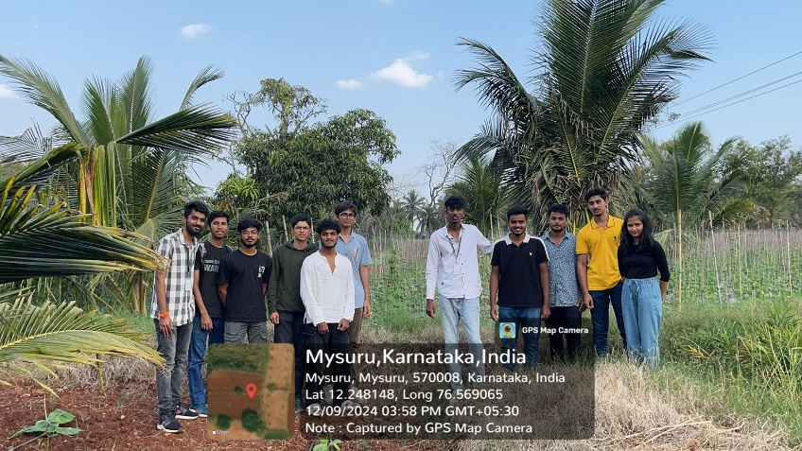**

To know more about organic farming and for keener observation our group members had been to Shri Manchegowda’s organic farm which is located at RT Nagar Mysuru which is a large organic farm with variety of produces occupying 6 acres. The farm included Banana plants, Ginger plantation, Grapes, Tender coconut and Pumpkin creepers. They use cow dung from their own cows as manure to all their plants with no chemical fertilizers. They also stated that the yield and profit of organic produce is more when compared to inorganic farming.

Banana Plantation:

Soil Selection**:** They have opted for well-drained, fertile soil.

Planting**:** They also suggested to choose disease-resistant banana varieties suitable for our climate. Plant suckers or tissue-cultured plantlets in well-prepared planting pits.

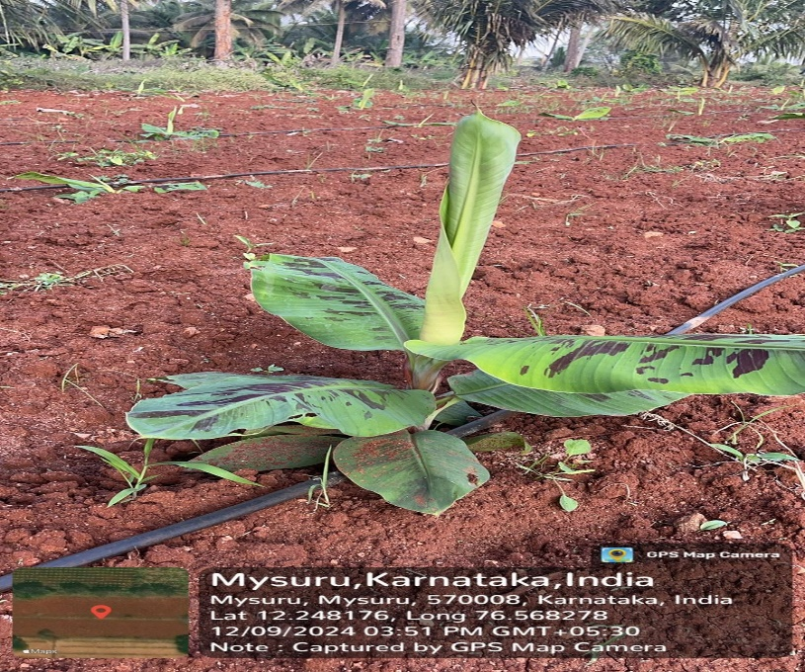

Ginger crop:

Healthy Rhizome: They also mentioned that choice of the plump becomes important and a firm ginger rhizome with several "eyes" or growth buds must be grown.

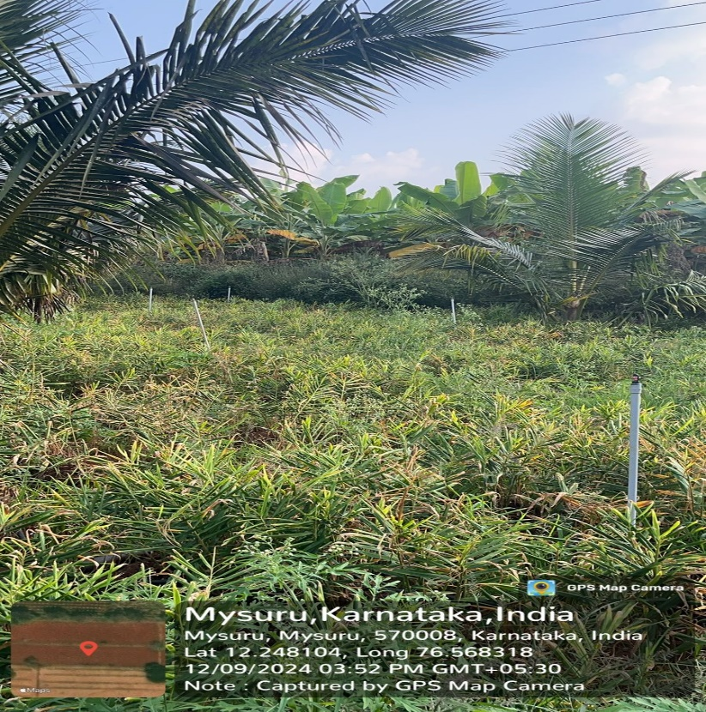

Grapes:

Climate: They have considered their local climate. Some varieties thrive in cooler climates, while others prefer warmer temperatures.

Natural Predators: They also encourage beneficial insects like ladybugs and lacewings.

Pruning: The vines are regularly pruned to remove dead or diseased wood and to encourage fruit production

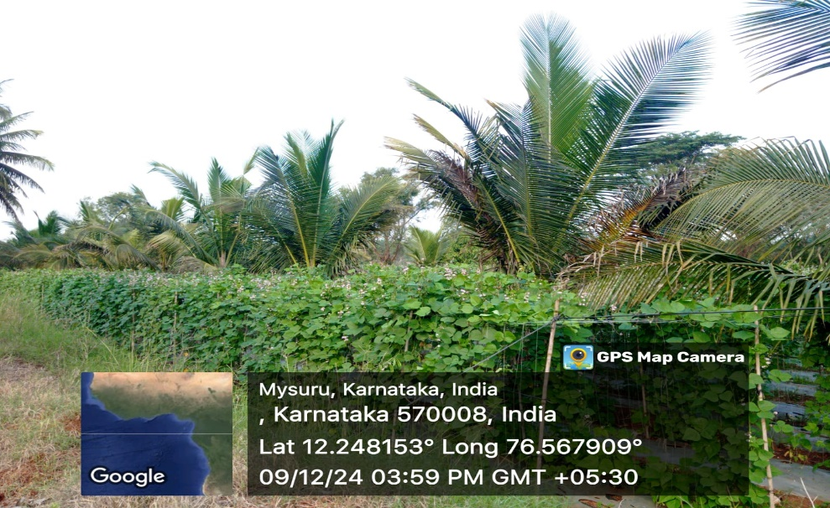

Tender Coconut:

Planting: The coconut plant should be planted horizontally, burying half of it in well-draining soil. The dark spot should be facing upwards.

Location: They have chosen a warm, sunny location with well-drained soil.

Watering: They also suggested that the coconut must be watered regularly, especially during the initial growth phase.

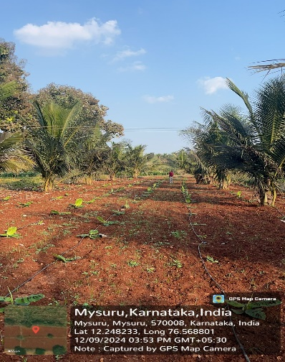

**Case Study 2: Visit to organic farmer Sri Shankregowda ‘s organic farm**

**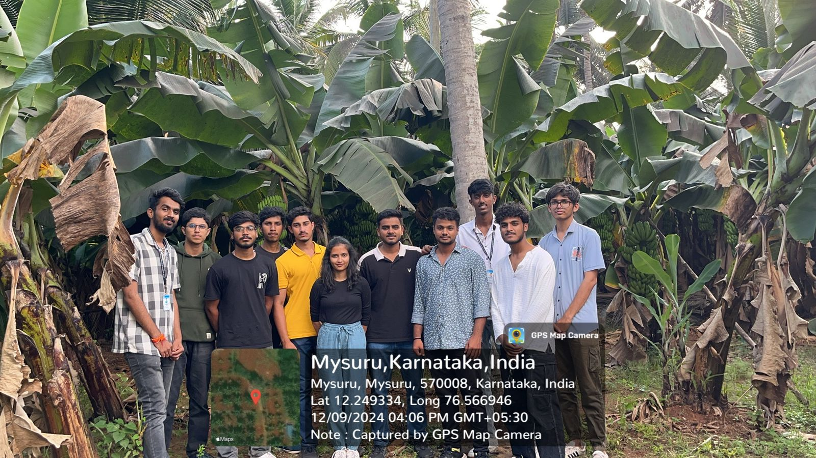**

For furthermore information and better comprehension our team continued our visit to Sri Shankaregowda’s organic farm which is just about 500 meters away from Manchegowda’s farm in RT Nagar Mysuru. The farm is extended over 5 acres and has about 10-15 crops and versatile plantations such as Colocasia, Chillies, Passion fruit, Lemon, Pulses, Banana plantation, Lentils, Papaya. They are also keeping bees for honey production which is termed as Apiculture.

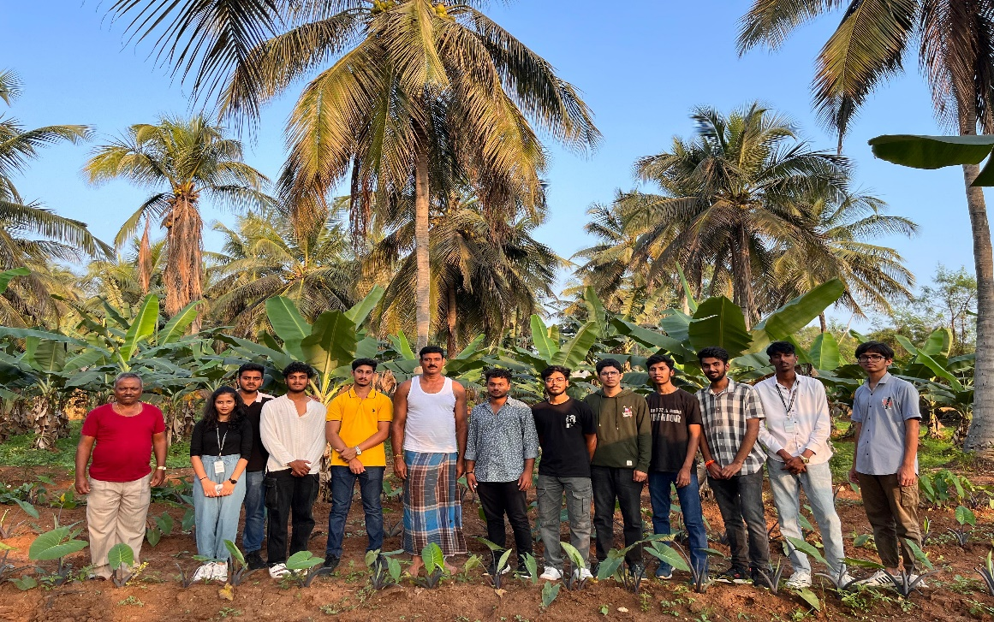

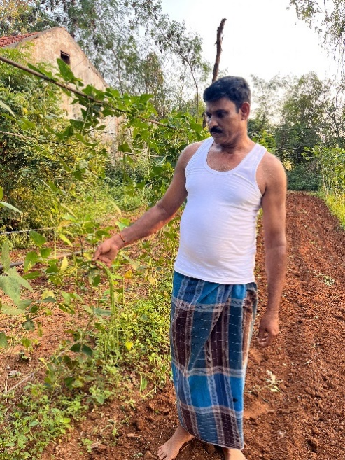 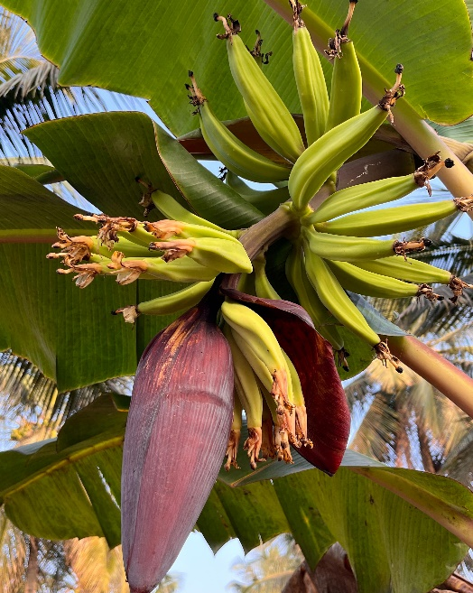

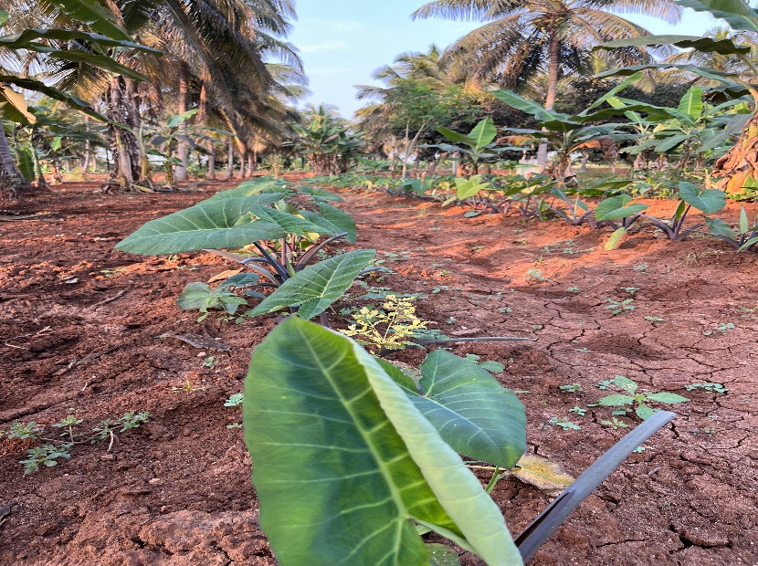

**Observations/Results**

* The farm utilized various techniques to maintain soil health, such as crop rotation, cover cropping, and composting. This resulted in fertile soil that was teeming with beneficial microorganisms.
* Pest and Disease Control: The farm relied on natural pest control methods, such as companion planting, attracting beneficial insects, and using homemade organic sprays. This minimized the use of harmful chemicals.
* Water Conservation: The farm implemented water-saving techniques, such as drip irrigation and rainwater harvesting. This ensured efficient water usage and reduced water wastage.
* Biodiversity: The farm promoted biodiversity by planting a variety of crops and maintaining natural habitats for pollinators and other beneficial organisms. This created a balanced ecosystem that supported sustainable agriculture.
* Freshness and Quality: The farm produced a wide range of fresh, high-quality, and nutritious fruits, vegetables, and other products. These products were free from harmful chemicals and pesticides.
* Nutritional Value: The organic produce was rich in vitamins, minerals, and other essential nutrients. This was due to the healthy soil and natural growing practices.

The visit to the organic farm provided valuable insights into the benefits of sustainable agriculture. The farm's practices demonstrated that it is possible to produce high-quality, nutritious food while protecting the environment and supporting local communities. The results of this visit highlight the importance of promoting organic farming and encouraging consumers to make informed choices about their food.

**Conclusions and Impact due to the project**

Organic farming in India has gained significant momentum, driven by increasing consumer awareness and government support. This shift towards sustainable agriculture offers numerous benefits:

Environmental Impact:

* Soil Health: Organic practices like crop rotation and composting improve soil fertility and structure.
* Biodiversity: Organic farms promote biodiversity by encouraging beneficial insects and microorganisms.
* Reduced Pollution: Eliminating synthetic pesticides and fertilizers minimizes environmental pollution.

Economic Impact:

* Premium Pricing: Organic products often command higher prices in the market.
* Export Potential: India can leverage its diverse agro-climatic zones to become a major exporter of organic products.
* Rural Development: Organic farming can create employment opportunities and improve rural livelihoods.

Social Impact:

* Healthier Food: Organic food is perceived as healthier and safer for consumers.
* Community Well-being: Sustainable farming practices contribute to the overall well-being of communities.

Future Outlook: To further promote organic farming in India, the following strategies are crucial:

* Policy Support: Government incentives and supportive policies can encourage farmers to adopt organic practices.
* Infrastructure Development: Investments in storage facilities and cold chains are essential for efficient distribution.
* Consumer Awareness: Educating consumers about the benefits of organic food can drive demand.
* Brand Building: Promoting Indian organic brands can enhance their global market presence.

By embracing organic farming, India can achieve a sustainable and prosperous agricultural future.

**Acknowledgement**

I would like to express my sincere gratitude to the following individuals and organizations for their invaluable contributions to 1 this research:

Dr Parameshwara P Sir, our NSS faculty coordinator for their valuable support.

Sri Manchegowda and Sri Shankaregowda for their generous hospitality and helping nature when our team visited their farm and for providing all the necessary information for our report.

**References**

<https://www.britannica.com/topic/organic-farming>

https://www.iberdrola.com/sustainability/organic-farming